Upper Extremity Block Safety:

* Support your arm by wearing a sling properly; ensuring your wrist is **fully** supported.
* Use a pillow to pad and support the numb extremity.
* Avoid placing cold or hot packs directly on the numb extremity.
* If a dressing, cast, or brace is present, check your fingernails frequently and alert your surgeon of any change in color.

Lower Extremity Block Safety:

* Use crutches or a walker since you **will not** be able to bear weight on the numb extremity. After full sensation returns, follow your surgeon’s weight bearing instructions.
* If a knee brace is provided, **do not** attempt to walk without it.
* Check your toenails frequently and **alert** your **surgeon** of any change in color.
* The numb extremity should be carefully padded and routinely repositioned to promote good circulation.

Close the clamp and call the Stanford Regional Anesthesia Service if you experience:

* Metallic taste in the mouth,
* Ringing in the ears,
* Dizziness,
* Rash or Hives,
* Fever,
* Confusion,
* Chest Pain,
* Numbness around the mouth,
* Seizures

|  |  |
| --- | --- |
| **Alert** | **Response** |
| Infusion Complete | The infusion is completed.  Press to silence the alert.  Press the key for 3 seconds to power off pump. |
| Upstream Occlusion | Decreased pressure is detected between the pump and the IV bag as if blocked.  Resolve the cause of the occlusion such as kinked tubing inside the carry pouch.  When resolved, the infusion will resume automatically. |
| Downstream Occlusion | Increased pressure is detected between the pump and the patient as if blocked.  Resolve the cause of the occlusion such as a closed slide clamp, kinked tubing, or tape covering the filter vent.  When resolved, the infusion will resume automatically. |
| Battery Depleted | Low Battery: The infusion will continue 30 minutes more.  Press to silence the alert.  Replace the battery using the instructions in the Patient Guide. |
| Pump Unattended | The power is on but the pump is in standby mode and not infusing.  Press  to silence the alert.  Press  then  to resume the infusion. |
| Max Vol Reached, Pump Standby | The pump has reached a maximum volume per hour or interval limit and will remain in standby mode until the new hour or interval is reached then will resume the infusion without requiring user action |
| Cassette Loading Error | Press to silence the alert. **Clamp the tubing**. Reattach the cassette following the instructions in the Patient Guide. **Open the clamp.**  Press again to return to the main programming screen.  Press  then  to continue the infusion. |





**Patient’s Guide to Ambulatory Pain Relief**



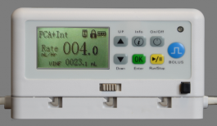

**To contact a Stanford Regional Anesthesia Service Doctor at any time day or night please call the operator at,**

**(650) 723-6661**

**And ask them to page #25625 (BLOCK)**

Patient support number: ( ) -

Nimbus 24/7 Support: ( 844 ) 479-8500

**What is a nerve block pump?**

* Your NimbusTM pain pump contains a numbing medicine that will help you control your pain for the next several days.

**Green** LED displays for 10 minutes

Volume remaining alternates with the Volume infused

Fluid bag icon displays while medicine is infusing

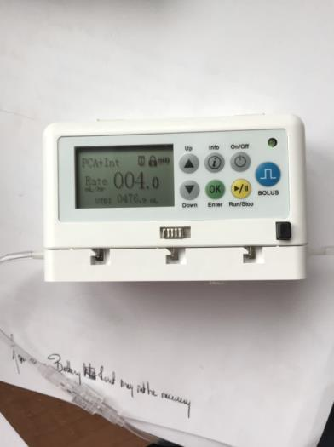

* 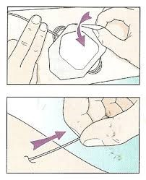It is attached to a catheter (small tube) near your nerves.

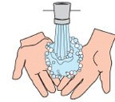

* The numbing medicine is being delivered to the nerves close to your surgical site.

**What do I need to know about the pump & catheter?**

* Your pain pump DOES NOT contain any “opioid” medication
* Your surgical pain should be controlled but may not be completely eliminated. That is normal.
* During your therapy if your pain becomes uncomfortable you will be able to press the blue Bolus button.
* It is okay to take ADDITIONAL ORAL PAIN MEDICATION to help control your pain.
* *It is normal that some leaking at the catheter site may occur.* If this happens**, reinforce** the dressing by applying gauze and securing it with tape.
* Do NOT WET the catheter, pump or bandages.
* Do NOT CHANGE the bandages.
* Do NOT DRIVE or operate potentially dangerous machinery while your catheter is in place or while you are taking narcotic medication.

**While the pump is turned on and infusing the pump will look like this**:

* There will always be information on the display screen. It will never go blank.
* When a button on the keypad is pressed, a *green* LED light will display for 10 minutes and then will turn offuntil the next time a button is pressed.
* Your infusion will end in approximately 3-4 days **or sooner** based on how often you request additional medication with the blue bolus button
* You will know the infusion is complete when the display looks like this:

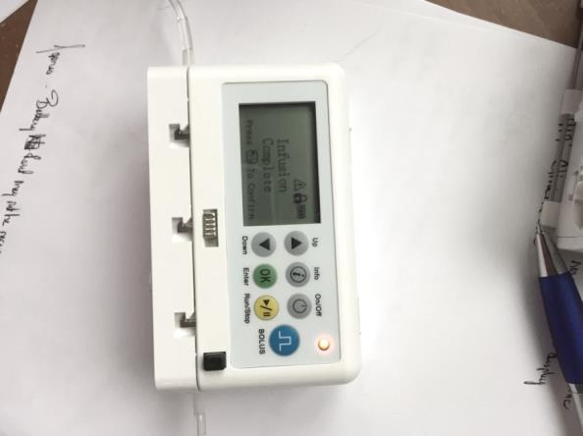

Flashing Red light

Alert icon displays 

VTBI reaches

“000” mL Infusion Complete alert is displayed



* At that time press the Run/Stop key to silence the “*Infusion complete*” alert.
* Then, TURN THE PUMP OFF by holding the ON/OFF key for 3 seconds.

**To remove the catheter:**

* Wash your hands and apply gloves.
* Peel off the clear dressing and tape that covers the catheter.
* Grip the catheter close to the skin and slowly but steadily pull the catheter out (2-6 inches). You may notice some tugging at the skin, this is normal. Continue to pull steadily.
* Inspect the tip of the catheter and call if it looks damaged.
* Do NOT CUT the catheter.
* After removing the catheter you can cover the site with a band aid if necessary.

**If you have any questions or concerns, call the** **Stanford Regional Anesthesia Service Doctor any time day or night,**

**(650) 723-6661**

**And ask them to page #25625 (BLOCK)**

Nimbus Pump 24/7 Technical Support:

(844) 479-8500 www.NimbusPump.com